**我的女兒在非洲**

**陳東榮 文 李芬芬 圖**

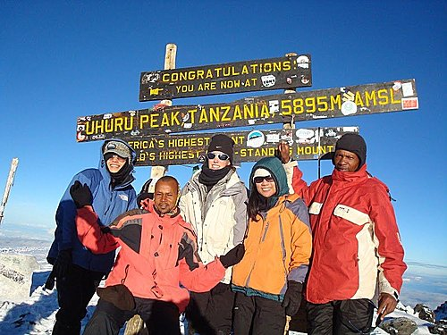  
**女兒(右二)登上非洲最高峰-- Mt.Kilimanjaro. 兩位男士是響導及託運幫手**

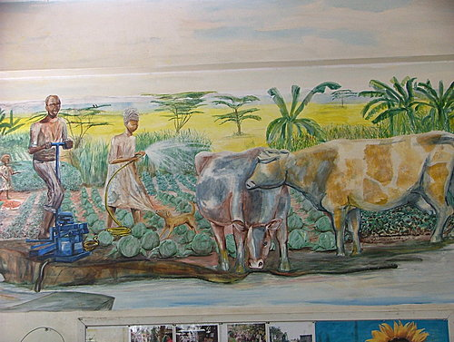  
**左下角是一台較大型的抽壓水幫浦,可以從溝中抽水,然後壓送至遠方,增加灌溉的面積.**

      我們在美國的第二代, 有不少年青人為了各種興趣, 職業及理想,跑到非洲,印度,中東等遙遠的地方. 這對於我們這群在台灣受過罐頭式, 千罐一律教育的父母們, 對於子女的這種選擇,往往是要經過一陣驚訝, 掙扎或衝突的過程, 然後就是接受或反對到底了.

    我家小女兒,自小活潑外向, 她在柏克萊讀企業管理碩士(MBA)的最後半年, 選擇到西非的加朋(Gabon),及蓋亞那(Ghana)去實習, 她告訴我們,這只是她在畢業前的一個機會, 到非洲去看看, 順便玩玩而已.

    她們在那裏幫助小企業人士創業, 也到窮鄉僻壤, 住在當地農戶家,學Swahili話, 教農民們怎樣使用手機, 當地手機都是從外國進口的便宜二手貨, 加上很多國際電訊公司搶奪非洲市場, 所以通話費用也非常便宜. 農民們一旦會用手機,當商人來收購他們收穫的農作物時, 他們就有市場資訊, 可以討價還價,不必被商人剝削, 為所欲為了.

    沒想到, 女兒畢了業, 竟然告訴我們, 她在非洲找到了她的"夢想的工作"(Dream job), 把她曾經工作了三年, 等著她修完MBA回去的美國工作(我們心中的夢想工作) 放棄了.

    女兒長大了, 自認為開明的我們, 雖然不以為然, 滿腹的牢騷也只能偷偷地跟朋友及其他兩位女兒說, 沒想到, 已有家室,兒女的兩位姊姊竟然說, 她們非常贊成, 也羨慕妹妹做這樣的決定.唉!! 真是有"代溝",真是"人老言輕, 沒用了".

    不但如此,女兒們還要去非洲看妹妹, 還要嘗嘗 Safari, 遊覽非洲大地的神奇經驗. 兩位女婿們更自告奮勇, 要拿假期,照顧共有五位的小孫兒們. 這樣一來, 我們兩老也決心萬里探女兒了.

    由夏洛特(Charlotte)到紐瓦克(Newark), 到倫敦,到奈羅比(Nairobi), 坐了十八小時飛機, 一共花了三十小時, 其中還在紐瓦克遇到大雪. 終於在傍晚抵達奈羅比. 飛機上看到的奈羅比市區竟然高樓大廈一座座, 是一個現代化的美麗大城市.

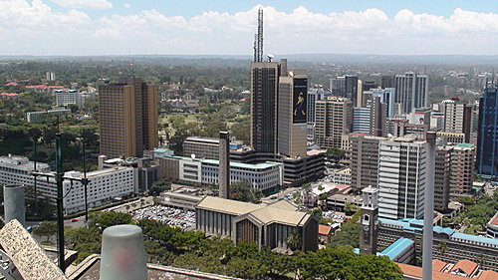

    女兒住的公司宿舍, 是一座新而現代化的大廈, 週圍綠蔭環繞,奇花異草. 宿舍裏面有五間浴廁俱備的套房, 寬敞的客廳和廚房, 卻只有兩位單身的小主管住. 奈羅比位居高原地區, 終年氣溫在七十度左右, 微風由窗外吹來, 四季如春. 加上有一位 煮飯洗衣的非洲女傭幫忙,設備, 用品應有盡有, 非常舒適. 我們頓然覺得賓至如歸, 甚至比正在冬天的夏洛特自已家更好了.



**女兒寬敞舒適的宿舍**

    宿舍附近有Shopping mall. 我們好奇,才剛下飛機, 就忍不住走去逛逛, 這裏屬於較高級的住宅區, Mall裏面有很多商店, 餐廳. 超市裏貨品也不少. 但它們的肉類都不像美國必須先經過冷凍才可使用, 都是溫體, 放肉類的櫃子溫度也不夠冷. 奈羅比雖然離印度洋不遠, 但因交通及冷凍條件不足, 海鮮很少, 大都 是醃製品, 後來在餐廳吃到的, 也都腥味很重. 超市裏的食物, 雜貨價錢都與美國差不多, 甚至更貴. 顧客大部份是住在附近的外籍及當地的中上階級人士. 一般老百姓則到市集去, 價錢就便宜很多. 我想這是因為交通不便, 運輸費高, 當地產物難以外銷,自然便宜, 但外來品就很貴.

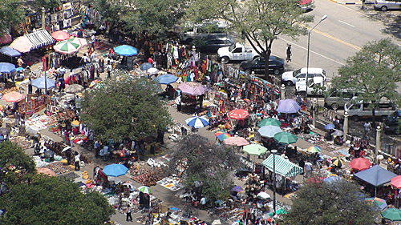  
**傳統的非洲市集, 這裏的東西便宜多了.**

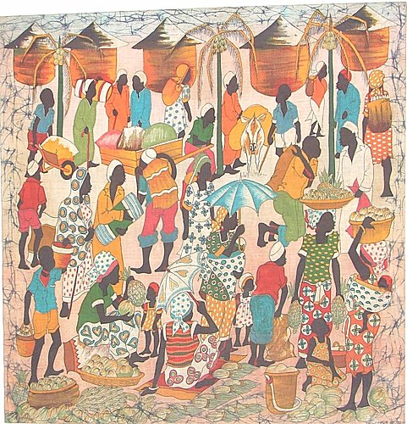

     後來,我們在走回宿舍的時候, 轉錯了, 竟然迷了路, 女兒正在開會不能出來. 奈羅比道路的中間柏油路是給車子走的, 旁邊的泥土路則給行人走. 我們在滿地灰塵,高低不平的土路上走了一個多小時, 終於遇到了一位開車的非洲婦人, 她自動地停下車來,好心地載著我們, 花了半個小時, 才把我們送回宿舍. 真沒想到,一到非洲,馬上受到非洲人的援助.

    奈羅比是一座國際性的大城市, 人口四百萬, 是肯亞首都, 也是從殖民時代以來,金融,經濟,文化的中心. 在這裏可以看到懸殊的貧富差距, 及優越與自卑感的強烈對照.在光鮮的大廈,及寬廣優雅的高級私人莊園群中間, 有破落的貧民區. 計程車在柏油路及土石路間轉來轉去,車子震得令人頭昏. 隨地燒垃圾的橡膠煙味, 加上揚起的風沙與汽車的油煙令人窒息. 奇怪的是人人毫不為意. 帶上我們自已的口罩,反而引起路人驚訝的眼光. 司機說,這裏只有生病的人, 才戴口罩.我問他, 這裏有很多慢性氣管炎的病人嗎? 他說沒有. 至於這裏人的平均壽命? 他說是五十七歲!! 難怪,奈羅比很少看到老人.

    在這裏,好的餐廳都是座落在一座座很大的莊園, 進入林蔭小道,然後在花園中的樹蔭裏, 或在星光下, 露天飲宴.奈羅比的料理應有盡有,印度,地中海, 中東的美食更是常見. 我們也去過日本餐廳, 非常道地,生魚片很新鮮, 一定是空運來的.

     在奈羅比, 所有較高級的餐廳,住家, 商場都有警衛, 鐵門守護, 據我觀察, 治安並不是大問題. 還有其它原因. 我猜想,就像台灣的豪宅一樣, 一是老習慣, 一是優越感的象徵.

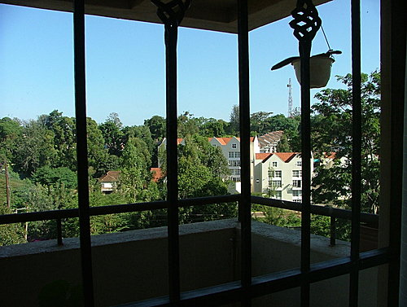

**宿舍裏像動物園一樣的鐵欄柵,人住其中,不知是牢裏牢外?台灣的陽台也是如此.**

    女兒在一家非營利機構工作. 名叫 Kickstart International ([Kick Start](http://www.kickstart.org/)). 她是負責營運及創新的主管. 非洲大部分人以農業為生. 說是農業, 其實企業性的農業很少. 大多的農家指的就是在房屋周圍種種蔬菜, 豆類, 玉米的家庭, 而且大多是婦女在負責. 由於灌溉範圍及土地有限,生產量少, 只能供自家使用. 非洲是世界七大洲中惟一無法自已生產足夠糧食的地方. 一般人民往往吃不飽飯.

     過去,許多國家或慈善機構, 往往以金錢,糧食來援助非洲人民, 但是這些資源不是被政府官員私吞或濫用, 就是把人民養成依賴, 懶惰的習慣. 因為這個原因,Kickstart與其它機構就想出了另外一種策略, 那就是"送魚不如教他們養魚,捕魚". 要他們自已站起來, 自力更生.

    所以,Kickstart研究, 製造了一些簡單, 便宜, 又堅固的工具, 如人工幫浦(Money Maker water pump); 人工榨油機等來推銷. 非洲的電力不普遍, 但人工便宜. 一家人買一座搾油機, 就可以開一個搾油坊, 替全村人搾油賺錢. 一家人買了一個像腳踏車打氣筒一樣的幫浦, 就可以把溝裏的水抽上來, 然後推壓到更遠的地方去灌溉,不必再挑水桶澆水, 就可以擴大灌溉的範圍. 這樣食物的產量及品質就會改善了. 即使不夠出售,增加收入, 卻可以減少挨餓.

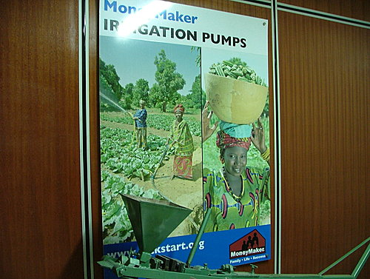  
**公司的人工幫浦及搾油機廣告**

    這個幫浦只售美金35元,非常耐用. 但是,即使以這個數字 ,對一般的農家, 仍然是一件大投資. 女兒就是以她在資訊及企業管理的專業, 下鄉建立營業網, 建構消費者與銀行, 慈善機構的管道, 幫助消費者拿到貸款.(Micro-loan).這樣子. 深入基層, 一戶一戶的達成. 雖然辛苦,但確踏實. 有趣的是,在 我們從倫敦到奈羅比的飛機上, 跟我們坐在一起的鄰座, 就是聖路易華盛頓大學的一位社會糸教授. 我們談起來, 她竟然是專程要到非洲來訪問Kickstart的用戶,做統計看看Kickstart的小幫浦, 對農家的營養質及量有什麼程度的改善? 可見Kickstart的模式已經受到學術界的重視.

     根據統計, Kickstart 以這種方式,己經在非洲幫助了五十六萬人脫離貧窮, 這對廣大的非洲是一個小數目, 但星星之火可以燎原.

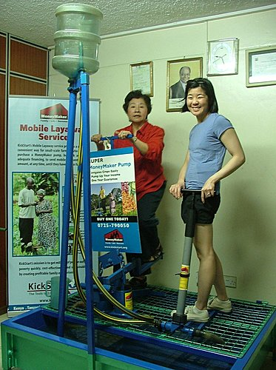  
**右為美金$35元的小型幫浦抽送水機,左為大型幫浦,用來增加灌溉範圍,增加收成**  
  
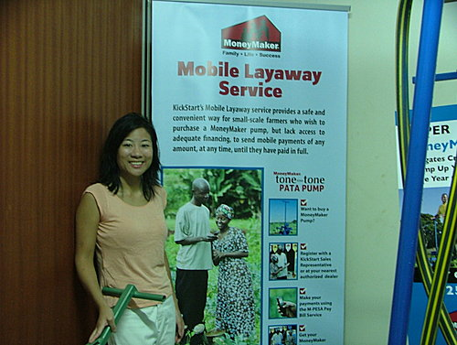  
**也有分期付款的服務**

   女兒告訴我, 非洲的工作, 也許在我們傳統台灣父母的眼中, 不是一件賺高薪, 炫耀地位的事,但是在非洲, 她學習了謙卑, 也體會了自巳的幸運, 更發現人生除了金錢, 名位的追逐之外, 能夠享受自然, 與種種不同文化, 財富,性格, 背景的人合作相處, 讓人更加成熟. 何況她的收入也不錯, 生活環境也很舒適. 加上非洲是一個企業管理,科技引進的新生地, 處處都有可以鍛鍊及發揮所長, 創造事業的機會. 以後回到美國, 這都是企業界非常需要的經驗. 但是最令她著迷的, 就是看到那些貧窮受苦的人,只 要我們一點點的付出, 就可能改變一個人, 一個家庭的命運. 這是在富裕的美國難以做到的. 何況,她從那些非洲人得來的真情感謝與熱情, 更不是金錢, 地位可以買到的. 在與其他在非洲的其他年青人深談以後, 我發現包括我女兒在內, 他們都不是不食人間煙火的超理想主義者, 他們大都跟我女兒一樣, 要在年青有熱情,有衝勁的時候, 還沒有受家庭之牽掛之前, 為非洲做一些奉獻, 同時也汲取經驗,豐富人生.  
  
    她答應我, 再過幾年, 她還是會回到美國成家立業, 替我們多生幾個孫兒!  
  
   話雖這麼說, 但是每次聽到女兒提起她到非洲邊遠貧窮的農家, 住在沒有電燈的草屋, 渡過一片烏黑, 趕打不盡蚊子的難眠長夜, 我的心就是無限的不捨. 不過她卻引以為傲. 望著她提起她用Swahili語與那些農家婦女談家常及受到她們熱情歡迎的得意神情. 我不禁自忖, 我們這兩位平凡的父母,怎麼會生來這位這麼有愛心的勇敢女兒?

全文完

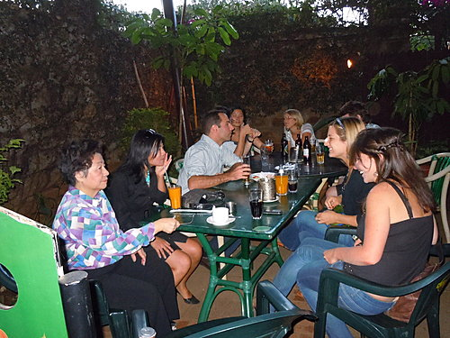  
**除了小女兒,也有很多的年青人也在非洲服務,奉獻.**

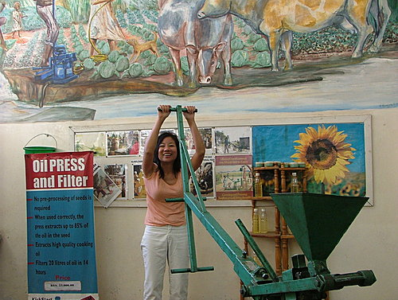

**搾油機使用示範**

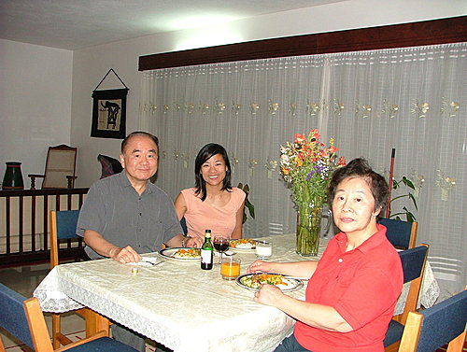

**在宿舍中快樂的午餐**  
  
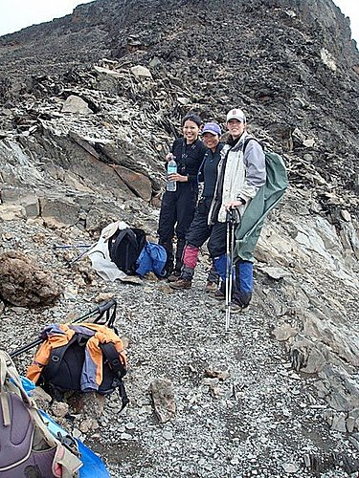  
**女兒在Mt. Kilimajaro 登峰途中**  
  
**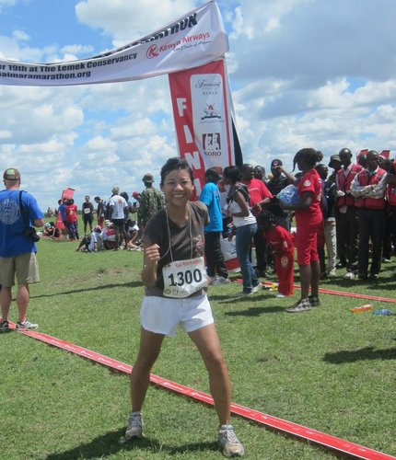  
參加肯亞 Masai Mara 國家野生公園的半馬拉松(Half Marathon)競跑**

|  |
| --- |
|  |
| This week Forbes Magazine published the [Impact 30](http://tracking.etapestry.com/t/22080494/810177659/54663379/0/), a list of the world's leading social entrepreneurs. KickStart is on the list at #7 ! We are honored to be in the company of so many respected and forward-thinking organizations, including Root Capital and One Acre Fund. |

[http://onforb.es/ KSImpact30](http://tracking.etapestry.com/t/22080494/810177659/54663381/0/)

Secretary Clinton Presents the Innovation Awards for the Empowerment of Women

http://www.youtube.com/watch?feature=player_detailpage&v=Me7fzC3f-BI#t=1036s

我女兒的部落格:

The past 4 years, I have celebrated the 4th of July in Africa (Ghana, Uganda, Seychelles, and Kenya). To honor both the country where I was born and raised and the continent that has become my home, I list a few of my favorite things:  
  
Things I miss most from the U.S.:

My family and friends

Celebrating the birthdays of my 6 adorable nephews and nieces

Weddings

Soul food

Fast food, especially Chik-fil-a and In 'n Out

Cheap regional flights

Being able to use a credit card to buy a $3 smoothie

Retail therapy

Clean and fast public transportation

Long summer days and warm summer nights

Things I love most about Africa:

Working with rural farmers

Meeting great people who are also passionate about social entrepreneurship and sustainable development

Scuba diving in the Indian Ocean

Riding random animals like camels and ostriches

Wild adventures like white water rafting the Nile, swimming with whale sharks, and gorilla trekking

Kickstart History

The Beginning of the End of Poverty

To read the news on a regular basis, it is easy to think that Africa is hopeless--civil wars, AIDS, genocide, drought, famine. It becomes easy to blame the lack of progress in eradicating poverty (or more accurately, the increasing problem) on natural or man-made disasters.

But statistics and grim headlines mask the real problem. The reason efforts have failed is because they are the wrong efforts. Yet these same failed efforts are used over and over again.

KickStart was created to break this cycle and to create a new, successful, scalable, replicable, and sustainable solution to poverty. (There are a lot of buzz-words in that sentence, but for KickStart, each has a specific meaning and measurement, see "When we say..." for more information)

Front-Line Experience

KickStart founders, Nick Moon and Martin Fisher, have more than 40 years of combined experience fighting poverty in Africa. KickStart's radically different model grew from their personal experience and the lessons they learned on the front lines of this effort. Martin Fisher earned his Ph.D. in engineering from Stanford University. After finishing his degree, he realized that his training gave him three career options--the oil industry, the defense industry, or academia. None of these appealed to him.

Martin went trekking in the Peruvian Andes to ponder the direction of his life. It was in Peru that he first encountered Third-World poverty. As an engineer, he knew that the right technology could change the lives of millions of people. Martin realized that poverty presented perhaps the greatest engineering challenge facing mankind. And there he found his calling.

He returned to the States, won a Fulbright Scholarship, and went off to Kenya to study the "Appropriate Technology Movement." He planned to be in Kenya for ten months. He stayed for seventeen years.

Nick Moon spent his early childhood in the far reaches of the British Empire--first in India, later in Singapore. He went to England for his education. He was a talented scholar, but also a strong-willed idealist. He left school at age 17 to train as woodworker and craftsman. Nick's skills as a carpenter took him to projects around Europe and Asia. A small want ad for a French-speaking carpenter got him a job building a recording studio in Togo and his first experience of Africa.

He returned to the UK to start his own business restoring Georgian homes around London. The business was successful, but to Nick, unfulfilling. Wishing to use his skills in the service of others, he joined Voluntary Service Overseas (the British Peace Corps). In 1982, Nick came to Kenya to teach carpentry skills and small business management to poor youth in a rural village.

In 1985, after his stint with VSO, Nick joined ActionAid, to work on construction training and job development programs where he met Martin.

Academic Rigor Meets Common Sense

At ActionAid, Nick and Martin worked on many projects. They built schoolhouses. They designed and built complex water systems of dams, canals and wells. They ran programs to train craftsmen and set up enterprises to make tools. On the surface, these projects seemed successful, but when they went back to visit these projects, they found the schools unused, the water systems crumbling, the craftsmen unemployed and the enterprises out of business.

How could such well-intentioned and well implemented projects fail?

As scholars they realized they could learn as much from failures as successes, so they took a very rigorous look at the shortcomings of their own projects. What they found was that development projects fall into four categories, each with serious shortcomings.

Donation of Capital Equipment to a Local Community  
Africa is littered with broken down windmills, water pumps, generators, and tractors given to communities. These gifts are expensive, but the recipient communities lack the organizational skills, tools, spare parts and the cash needed to maintain or fuel this equipment. When these machines break down, they are rarely repaired or replaced, leaving the community no better off for the investment.

Donation of Tools and Equipment and Training to Start a Community Business  
Nick and Martin spent years providing tools, equipment, and training to local groups. Typically these businesses did not produce sufficient profits to provide operating capital, let alone to share among the many members. The survival of the businesses is dependent on the presence and subsidy of a development agency. So when Martin and Nick moved on, the business would fail because there was no strong entrepreneurial leader with a vested interest in making the business a success.

Donation of General Goods or Services  
Together they worked on programs that donated goods and or services to people in poor villages. But by its very nature, a giveaway program cannot be sustainable. No matter how large the charity, the distribution will end at some point and the organization will move on. Martin and Nick noticed that there were often private sector businesses in the community offering these goods or services for a fee. The giveaway programs were not only unsustainable, they often put private enterprises out of business--killing the entrepreneurial spirit. The result? The village is left without access to these goods and services, again leaving them worse for the investment.

Products That Save Time, Labor  
Nick and Martin were probably as guilty as any aid worker who assume that time and labor saving devices improve the quality of life. But what they came to see was that poor have an abundance of two valuable resources--their time and their labor. To minimize the value of these two non-cash assets, just pushes a person deeper into poverty.

The pair took their findings to their supervisors and other leaders of the major aid programs in the region. What they found were big bureaucracies closed to new ideas. Critical self-examination was not only discouraged, it was considered dangerous.

Nick and Martin remained convinced that there was a better way to address poverty--a model that would bring together the power of technology with the proven sustainability of the marketplace and private sector.

So in 1991 they founded ApproTEC, now KickStart and to date, Martin and Nick's innovation has helped over 559,300 people get out of poverty forever.

We’re Hiring

[Associate Product Manager-Kenya](http://www.kickstart.org/about-us/job-openings.php#p202)

[Water Level Researcher- Kenya](http://www.kickstart.org/about-us/job-openings.php#p201)

[Director of Government Relations - US Based (DC)](http://www.kickstart.org/about-us/job-openings.php#p196)

[](http://s04.flagcounter.com/more/3me)