2018 Newsletter by Anthony T. Tu, 杜 祖健、email: atucsu@gmail.com
Merry Xmas and Happy New Year
The year of 2018 was busy year for me. I went to Colorado twice by driving about 1,200 miles each way. I visit my children in Princeton, NJ, NYC, Denver, and Boulder. I could not go to see Caroline in WI. I visited Hawaii twice,once with Mr. and Mrs. Masuno. I visited Japan 4 times and Hong Kong twice. Several friends came to see me from Japan( Mr. Yoshida, Mr. Yasufuku, Dr. Takagi and we went to Colorado, NJ, and NYC together.
For my invited lecture, I was in Czech Republic’s “Future Force Forum” and Czech Government gave me a plague in October. I was also a lecturer for NATO Course in Ankara, Turkey in December. I gave 3 lectures to 33 military officers from 16 countries. NATO gave me a plague and a document of appreciation. Many officers personally talked with me saying the lectures were very good.
My 5 children are fine. I have 4 grand-children. One is Grace who work at Duke University and gave a talk on her research of jumping larvae. Her talk was cited in Nature. Another grandson, Logan’s Taft University’s dissertation was attaching a chip to a teeth and can find out what kind of food one takes. His work was mentioned in Smithsonian Review. The third granddaughter, Brooke was an intern at the State Department. The forth granddaughter, Nicky was instructor for sailing boat during the summer.
In 2018 I visited Dr.Tomomasa Nakagawa in Tokyo Detention Center on March 13 and the last visit in Hiroshima on April 11 at Hiroshima Detention Center. He was executed by hanging on July 6 in Hiroshima for murdering 25 people. On March 13 meeting I thought it was funny that an officer told me I can talk a little longer. Usually a talk with Dr. Nakagawa was only 30 min. Another strange thing was that a high ranking officer escorted me to a meeting room without going through metal detection system. Moreover he sent me off to an exit gate. Next day 7 death row inmates were transfered to other detention center next day that has hanging facility. The news of transferring was a big news in Japan. I guess detention center’s officers must know Dr. Nakagawa would be transferred to other places next day. I guess they felt I came all the way from America to see Dr. Nakagawa, therefore,they gave me special treatment. The last letter I received from Dr. Nakagawa was 4 days before he was executed. It was very sad feeling that he left the earth permanently. As I promised I published the conversation with him after his death.
Dr. Nakagawa told me that he would like to publish VX work he did to kill one parson and injured 2 people and also on assassination of Kim Jong-nam in Malaysia. So I wrote a letter to the editor short article to Forensic Toxicology that was published on June 21, I wrote the article but put his name as the first author. The reaction of this paper was fantastic and 2,700 people download the article by July 1. Accoding to Germany’s Research Gate the article was read by 1,720 people by Nov. 1. Only 2 parsons were permitted to interview Aum Shinrikyo’s death row inmates by the Japanese Government, one is me and the other parson was Mr. Danzig of former Navy Secretary during the Clinton Administration.
My book,” the Conversation with Dr. Tomomasa Nakagawa, an Aum Shinrikyo’s death row inmates” was published on July 26 and went for 3rd printing of 10,000 copies. I gave 20% royalty to his family.
My sister passed away at the age of 95. Since I was in Japan so I sent my children Caroline and Alan to Taiwan to attend the funeral. They were happy to see many other cousins they did not know before. They also visited my mother’s mansion, my sister’s family mansion, and many bronze stature of my father and memorial museum.
With all stories I am concluding 2018 Newsletter. I hope we can maintain our mutual friendship.
Tony in San Mateo, California
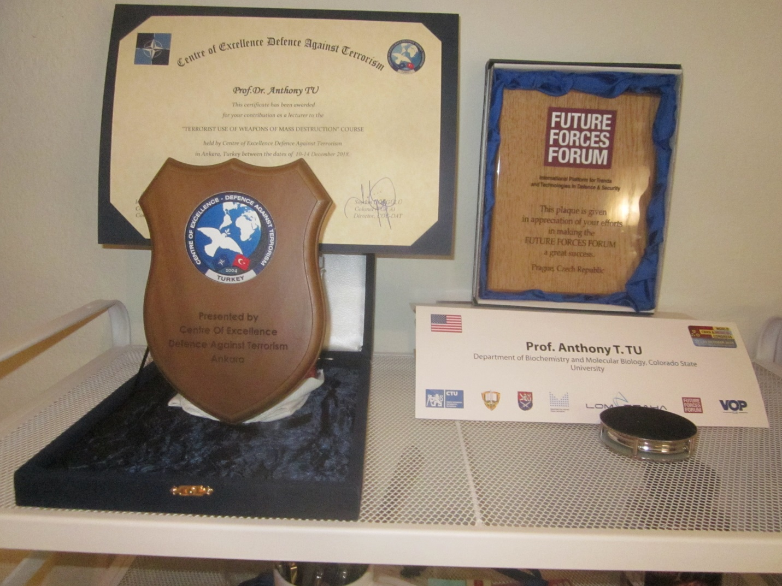
Left: Plague from NATO; Right: Plague from Czech Republic Government

