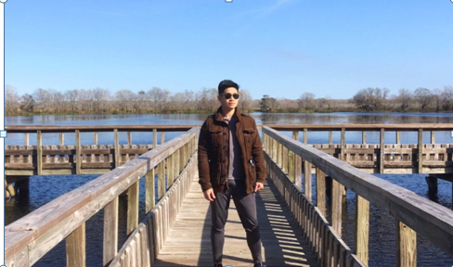
Today we’d like to introduce you to Chih-Chien Chou (周志謙) - THSH Fitness Club Coach (VoyageHouston 專訪周志謙教練)
So, before we jump into specific questions about the business, why don’t you give us some details about you and your story.
In 2009, I moved to the United States from Taiwan to pursue my Ph.D. at Ohio State University. During my time as a doctoral student, I went to the gym at least three times a week so I can deal with the stress of daily life. Shortly after finishing my doctoral degree, I worked as a Postdoctoral Fellow at Stanford University in California. Two years later, I would come to MD Anderson here in Texas as a Postdoctoral fellow in the Immunology department. At the same time, I was still hitting the gym hard to better myself. One thing I realized as a Cancer Researcher, is how devastating and crippling this disease is. Not only does it drag you down physically, but mentally as well. Since studying Immunology in cancer, I realized that everyone should develop and train their Immune System. In my mind, that correlates to healthier eating and physical training. Doing both has a unique way of bolstering the body defenses against bacteria, viruses and even cancer. I believe that “Exercise is cheaper than therapy and food is the best medicine in the world.” These are two things that everyone should invest time and effort in.
Great, so let’s dig a little deeper into the story – has it been an easy path overall and if not, what were the challenges you’ve had to overcome?
Life’s road is never really smooth. When you get to those bumps, I view that as a chance to grow and conquer the obstacle and become a better person because of it. My personal fitness journey has had its share of those bumps. In the past, I had no know knowledge of working and dieting. I just simply did whatever I felt to get rid of body fat and gain muscle. If two years of not seeing the results I desired, I realized how much time, money, and effort I wasted without doing the proper research. Finally doing the proper research and also talking to various experts, I reworked my diet and workout regimen. Being consistent with a well-planned physical workout and diet program, did I begin to see the results that I desire. I also believed that it helped with something else, aging gracefully. Would you believe that I am actually 38 going on 39? I know genetics play a role, but I believe diet and exercise help our genetics express anti-aging effect of a greater scale.
Alright – so let’s talk business. Tell us about Majestic Natural Fitness – what should we know?
I currently hold a young professional workout club at the Taiwanese Heritage Society of Houston near China Town. The main purpose of this club is to help people develop their workout habits and also share the knowledge of a healthy diet. During class, I coach our members on how you to use various types of fitness equipment to train the various muscles within the body. We use dumbbells, resistance bands, and also battle ropes. We also perform various High-Intensity Interval Training (HIIT) routines. HIIT routines are a very efficient in fat burning and also muscle endurance. In conjunction with this class, I have also created a Facebook fan page (Possible Website in the Future) where I offer workout tips, fitness knowledge and also scientific studies to the members of the group. One thing that I am proud of as an amateur fitness coach is how motivated and dedicated my members are. They have a strong desire to be fit and that really helps me to push them to not only be fit but also gain more confidence within themselves. All I want is to create to friendly, positive, and motivated fitness community for my club members. I believe this sets me apart differently from others.
Is there a characteristic or quality that you feel is essential to success?
Passion and connection to others are the two most important things that I believe have brought me to my success. Passion is my driving force that motivates me with my fitness to never get tired of it. I tend to focus on what I am passionate about, this pushes me to be the best I can be at it. This is why I continue to post motivating pictures of myself and of my club members on social media. This is also how I created my fitness club at the Taiwanese Heritage Society of Houston. One of my friends as me to start my fitness club and here we are today. I viewed this as the way to connect with others. I seized my opportunity to be a fitness coach to connect with others by helping them develop workout habits and also a healthier lifestyle. I am looking forward to seeing how great of a success I can be along with the others that I coach.
http://voyagehouston.com/interview/meet-chih-chien-chou-majestic-natural-fitness-china-town/?fbclid=IwAR3sktk7o9JrzcQg4V-HdYiW0kjZR_Af5XzOdhBzWNWWBuEVxmKUOP6ny3o
公告: Young Professional Workout Club Coach 周志謙先生因工作要搬到加州，所以11月17日將是最後一次的Fitness Workout Session.

